**FRAUDGUARD**

A Project Report

submitted in partial fulfillment of the requirements

of

**Applied Artificial Intelligence**

by

**Harshit More, 160110722061**

**Meet Solanki, 160110722025**

**Hardik Parmar, 1601107220**

**Vishal vishvakarma, 160110722049**

Under the Esteemed Guidance of

**Jay Rathod**

**ACKNOWLEDGEMENT**

We extend our heartfelt gratitude to everyone who contributed to the successful completion of our project, the FRAUDGUARD App.

First and foremost, we wish to express our deep appreciation to our mentor, Jay Rathod Sir. His invaluable guidance, encouragement, and unwavering support throughout this project have been pivotal. His expertise and constructive feedback have shaped our work significantly, inspiring us to tackle challenges and strive for excellence.

We are equally grateful to our mentors and colleagues in the TechSaksham Program. Their insights, resources, and collaborative environment have enriched our learning experience, enabling us to apply our knowledge in AI, ML, and NLP with confidence and precision.

A special acknowledgment goes to our fellow team members, whose dedication, hard work, and team spirit made this project possible. Each member’s unique skills and contributions were instrumental in bringing the FRAUDGUARD App to life.

Finally, we express our deepest gratitude to our families and friends. Their unwavering support, patience, and encouragement have been invaluable throughout this journey.

Thank you all for making this achievement possible.

#### ABSTRACT

This project is a Flask-based web application designed to detect and analyze potentially harmful URLs and email content. It incorporates various security checks to identify phishing attempts, spam, and other malicious indicators. The application leverages APIs from Google Safe Browsing and VirusTotal to cross-check URLs for blacklisting and malware detection. Additionally, it performs checks against a locally maintained list of phishing sites and employs pattern-based detection to identify suspicious URLs and content.

The project also provides analysis on email content by flagging common spam keywords and suspicious phrases. For URL submissions, it fetches and displays page metadata (such as titles and descriptions) and examines links for phishing indicators. Users can provide feedback on the results, which is logged for future analysis. The app's interface offers an educational section to inform users about phishing and online security practices.

**TABLE OF CONTENTS**

• Abstract …….................................................................................................................... i

• List of Figures ……........................................................................................................... ii

• List of Tables ……........................................................................................................... iii

Chapter 1: Introduction ……...................................................................................................... 5

1.1 Problem Statement ……....................................................................................................... 6

1.2 Problem Definition ……........................................................................................................ 7

1.3 Expected Outcomes ……....................................................................................................... 7

1.4 Organization of the Report ……............................................................................................ 8

Chapter 2: Literature Survey ……................................................................................................ 9

1. Spam and Phishing Detection Techniques………………………………………………………10
2. URL Analysis in Phishing Detection……………………………………………………………10
3. User Education and Awareness in Cybersecurity……………………………………………….11

Chapter 3: Proposed Methodology ……..................................................................................... 12

1. **Data Collection and Feature Extraction…………………………………………………….13.**
2. **Real-Time Processing……………………………………………………………………...…13**
3. **User Education Module………………………………………………………………………13**
4. **Frontend and User Interface Design………………………………………………………...14**
5. **Result Display and Feedback………………………………………………………………..14**
6. **Testing and Validation…………………………………………………………………….…14**

Chapter 4: Implementation and Results ……............................................................................. 15

1. **Implementation……………………………………………………………………...……..16**

* **Backend Development…………………………………………………………………..17**
* **Frontend Development……………………………………………………………………17**
* **User Education Module…………………………………………………………………18**
* **Testing……………………………………………………………………...……………….18**

1. **Results……………………………………………………………………...………………..18**

* **Effective Phishing and Spam Detection…………………………………………….18**
* **Increased User Awareness……………………………………………………………18**
* **Improved User Experience……………………………………………………………19**
* **Positive Usability Feedback……………………………………………………………19**
* **Performance and Security……………………………………………………………..19**

Chapter 5: Conclusion .............................................................................................................. 20

* conclusion**……………………………………………………………………...………………21**
* advantages……………………………………………………………………...……………….22
* scope**……………………………………………………………………...……………………..22**

**LIST OF FIGURES**

|  |  |  |
| --- | --- | --- |
|  |  | **Page No.** |
|  | Welcome text | **23** |
|  | Main body of url and email input | **23** |
|  | About us section | **24** |

References **……………………………………………………………………...………………..25**

appendix……………………………………………………………………...………………………..26

**CHAPTER 1**

**INTRODUCTION**

**CHAPTER 1**

**INTRODUCTION**

1. **Problem Statement:**

**The problem addressed by this project is the increasing risk of users falling victim to malicious websites, phishing attacks, and spam email content that can lead to data theft, financial loss, or compromised security. With the growing sophistication of cyber threats, users need a reliable tool to help assess the safety of links and emails before interacting with them. Existing antivirus software and basic email filters may not always catch all threats, particularly new or targeted phishing scams, leaving individuals vulnerable.**

**The project aims to create a web-based solution to help users quickly analyze URLs and email content for potential malicious indicators, such as phishing attempts, spam keywords, and suspicious domains. By integrating multiple threat detection mechanisms—such as VirusTotal API checks, Google Safe Browsing, and phishing indicators based on domain and content analysis—the application provides a comprehensive assessment to help users make safer online decisions.**

1. **Problem Definition:**

**With the proliferation of cyber threats, users are increasingly exposed to malicious URLs, phishing attacks, and spam emails designed to steal information, spread malware, or conduct scams. Current solutions, such as basic email spam filters and antivirus software, often lack the robustness to detect complex or emerging threats, especially in real-time and across various domains. Phishing websites and emails exploit user trust by mimicking legitimate sources, leading to a high risk of data breaches and financial losses**

1. **Expected Outcomes**

**• Increased Awareness: Users will gain a better understanding of phishing and spam characteristics, leading to safer digital practices.**

**• Enhanced Security: FRAUDGUARD’s analysis tools will help users avoid phishing and malicious links, reducing risk of scams.**

**• User Confidence: With tools for content verification, users will feel more confident handling unfamiliar emails and links.**

**• Easy Accessibility: The intuitive design ensures that users of all backgrounds can navigate the app and stay informed.**

**• Immediate Feedback: Real-time analysis, including keyword highlights and URL checks, provides users with instant, actionable insights**

1. **Organization of the Report**

**This report is structured to provide a comprehensive view of the Secret Keeper App’s development, from concept to implementation:**

Chapter 1: Introduction Discusses the problem the app addresses, the project’s objectives, the expected outcomes, and an outline of the report structure.

• Chapter 2: Literature Survey Reviews relevant literature and existing solutions in data security, focusing on the integration of ML in authentication and data analysis.

• Chapter 3: Proposed Methodology Describes the architecture, key modules, and technologies used in developing the app, including ML-based facial recognition.

• Chapter 4: Implementation and Results Provides an in-depth look at the app’s implementation, covering technical specifications, feature descriptions, and a discussion of results.

• Chapter 5: Conclusion Summarizes the achievements, limitations, and potential future enhancements for the fraudguard App.

**CHAPTER 2**

**LITERATURE SURVEYCHAPTER 2**

**LITERATURE SURVEY**

**1. Spam and Phishing Detection Techniques**

Machine Learning and AI in Spam Detection: The application of machine learning and artificial intelligence to detect spam has been widely researched. Techniques such as Naive Bayes, Support Vector Machines (SVM), and deep learning models have proven effective for email filtering by analyzing content and behavioral patterns. Studies by Sahami et al. (1998) introduced Bayesian filtering as an early and reliable method for spam detection, while more recent work by Zhang et al. (2018) demonstrates the power of deep learning in improving detection accuracy by identifying sophisticated phishing attempts.

Natural Language Processing (NLP) for Phishing Identification: Phishing emails often contain specific linguistic cues, such as urgency or financial incentives, making NLP a valuable tool for phishing detection. Research by Bergholz et al. (2010) shows how text-based features, like language patterns, can differentiate phishing from legitimate emails. By extracting features such as keywords, phrase structures, and context, NLP techniques enhance the classification accuracy of email analysis systems.

**2. URL Analysis in Phishing Detection**

URL-Based Detection Methods: URLs in phishing emails are often manipulated to appear legitimate, making URL analysis a critical area in phishing detection. Works by Ma et al. (2009) introduced a feature-based approach to URL classification, identifying suspicious patterns in URL length, domain reputation, and special characters. More recent studies, such as those by Le et al. (2018), use machine learning algorithms to detect phishing URLs by analyzing lexical and host-based features, making URL validation a powerful first step in identifying phishing attempts.

Real-Time Phishing Detection Systems: Real-time detection of phishing URLs has become crucial as threats evolve. Homograph attacks and typosquatting (using lookalike characters and domains) are common in phishing URLs, as explored in research by Invernizzi et al. (2014). These studies underline the importance of integrating real-time URL validation, as implemented in FRAUDGUARD, to alert users about suspicious links without delay.

**3. User Education and Awareness in Cybersecurity**

The Role of User Education in Phishing Prevention: Numerous studies highlight that user education is as important as technical measures for cybersecurity. According to Kumaraguru et al. (2009), educating users about phishing techniques significantly reduces their likelihood of falling victim to online scams. Awareness campaigns and in-app guidance improve users' understanding of online threats, supporting proactive security behavior.

Interactive Training Approaches for Cybersecurity Awareness: Research shows that interactive, practical training is more effective than passive learning for cybersecurity awareness. Work by Alqarni et al. (2016) suggests that apps that incorporate user education, interactive guidance, and real-time feedback (as in FRAUDGUARD) are more likely to help users develop a keen eye for phishing indicators, increasing overall online safety.

**CHAPTER 3**

**PROPOSED METHODOLOGYCHAPTER 3**

**PROPOSED METHODOLOGY**

**1. Data Collection and Feature Extraction**

* **Email Content Analysis: The application scans user-provided email content to identify patterns indicative of phishing or spam. It highlights keywords associated with phishing (e.g., "urgent," "free," "click here") to alert users to potential threats.**
* **URL Analysis: User-inputted URLs are validated using key characteristics such as domain reputation, URL structure, and lexical analysis. Suspicious elements, such as typosquatting or unexpected characters, are flagged for further inspection.**

**2. Real-Time Processing**

* **Keyword Highlighting: JavaScript is used to highlight high-risk keywords in real-time as the user enters email content, providing immediate feedback on potential spam indicators. This feature uses regular expressions to detect keywords and visually emphasize them.**
* **AJAX-Based URL Validation: When a user inputs a URL, the app uses AJAX to send the data to the server asynchronously, allowing background processing without page refreshes. The server validates the URL, returning feedback on whether the link is safe or potentially harmful based on predefined criteria.**

**3. User Education Module**

* **Guided Tips and Best Practices: A dedicated "User Education" page provides information on recognizing phishing tactics and maintaining secure practices. This page includes advice on examining sender details, avoiding suspicious links, and enabling two-factor authentication.**
* **In-App Guidance: The application includes modal pop-ups and tooltips that guide users on how to input data and understand analysis results, reinforcing cybersecurity knowledge in a practical, accessible manner.**

**4. Frontend and User Interface Design**

* **Responsive, Accessible UI: FRAUDGUARD’s design ensures ease of use across different devices with a dark-themed, accessible layout. Buttons and input fields are designed with clear contrast and large fonts for readability, while the form layout supports intuitive navigation for users.**
* **Loading Feedback: To enhance user experience, a loading spinner is displayed while the system processes user inputs, keeping users informed and reducing uncertainty during analysis.**

**5. Result Display and Feedback**

* **Real-Time Result Feedback: Upon completion of email or URL analysis, results are presented in a modal dialog box, detailing whether the content or URL is safe, spam-related, or potentially phishing. Keywords or phrases flagged during analysis are highlighted, with accompanying explanations to help users interpret results.**

**6. Testing and Validation**

* **Usability Testing: Conduct tests with different user groups to ensure ease of use, accuracy of phishing and spam detection, and effectiveness of the education module.**
* **Performance and Security Testing: Ensure the application handles data securely, especially sensitive information entered by users, and runs efficiently across devices.**

**CHAPTER 4**

**Implementation and Result**

**CHAPTER 4**

**IMPLEMENTATION and RESULT**

**Implementation**

**The implementation of FRAUDGUARD involves building both the backend for processing inputs and the frontend for user interaction, following the proposed methodology.**

**1. Backend Development**

* **Framework: The backend uses Flask, a lightweight Python framework, to handle user requests and provide real-time responses.**
* **Email and URL Analysis:**
  + **The email content is parsed to detect common phishing keywords using regular expressions.**
  + **URL validation is conducted by checking structural attributes (length, domain reputation, suspicious characters) against a set of rules.**
* **API Endpoints: An API endpoint processes URL validation requests sent from the frontend via AJAX, responding with real-time feedback (e.g., safe, suspicious, or invalid URL).**

**2. Frontend Development**

* **HTML/CSS and JavaScript:**
  + **The HTML structure is styled using CSS and Bootstrap for a responsive and accessible user interface. Custom CSS enhances the visual experience with a dark theme, while animations provide a smooth user experience.**
  + **JavaScript is used for keyword highlighting, URL validation feedback, and interactive modal pop-ups.**
* **Real-Time Keyword Highlighting: A JavaScript function highlights suspicious keywords in email content, dynamically updating as users type.**
* **AJAX for URL Validation: The frontend sends URL input to the backend via AJAX, displaying feedback based on the server’s response (e.g., “Valid URL” or “Potential Phishing”).**

**3. User Education Module**

* **A dedicated HTML page provides cybersecurity tips and best practices.**
* **Interactive elements, such as buttons that trigger modal pop-ups with guidance, make it easy for users to access educational content without navigating away from the main interface.**

**4. Testing**

* **Usability Testing: User tests ensure that the app’s features are intuitive and effective.**
* **Validation and Error Handling: The system is tested for handling invalid inputs gracefully and providing clear feedback.**
* **Performance Testing: The app’s performance is monitored for response times, particularly during URL validation, to ensure a smooth experience across devices.**

**Results**

**The implementation of FRAUDGUARD yields the following outcomes:**

1. **Effective Phishing and Spam Detection: The application accurately highlights keywords associated with phishing and spam and provides real-time URL validation. This enables users to identify potentially harmful content before interacting with it.**
2. **Increased User Awareness: The education module and real-time feedback have been effective in raising user awareness. Users report a better understanding of phishing indicators and increased confidence in assessing email and URL authenticity.**
3. **Improved User Experience: The dark-themed, responsive design, combined with real-time feedback, enhances the user experience. The loading spinner and AJAX feedback keep users informed without disrupting workflow, creating a seamless experience.**
4. **Positive Usability Feedback: During testing, users found the interface intuitive, especially the keyword highlighting and educational guidance features. The modal pop-ups for explanations and guidance received positive feedback for being informative without overwhelming users.**
5. **Performance and Security: The app performs efficiently, providing instant feedback on inputs, and handles user data securely. Testing shows minimal latency, even when processing complex input data.**

**CHAPTER 5**

**CONCLUSIONCHAPTER 5**

**CONCLUSION**

**FRAUDGUARD successfully meets its objectives by providing users with a powerful, user-friendly tool for detecting phishing, spam, and suspicious URLs. Through its real-time analysis, keyword highlighting, and URL validation features, FRAUDGUARD enhances digital security, allowing users to identify potential threats effectively and safely. The application’s user education module empowers individuals with the knowledge needed to recognize and avoid online scams, contributing to greater overall cybersecurity awareness.**

**The project demonstrates the importance of combining technical detection mechanisms with accessible educational resources. FRAUDGUARD’s intuitive interface and immediate feedback create a positive user experience that is both informative and practical. This project underscores the value of proactive security measures, enabling users to navigate the digital space with increased confidence. Future enhancements, such as machine learning-based detection and multi-language support, could further improve FRAUDGUARD's impact, expanding its accessibility and accuracy.**

**In conclusion, FRAUDGUARD is a valuable tool for cybersecurity awareness and protection, serving as a practical, educational solution for users in an increasingly digital world.**

**Advantages of FRAUDGUARD**

1. **Real-Time Threat Detection: Provides instant analysis of email content and URLs, helping users quickly identify phishing and spam.**
2. **User-Friendly Interface: Intuitive design with real-time feedback ensures a smooth experience for users of all technical backgrounds.**
3. **Educational Resources: Empowers users with tips and best practices, increasing cybersecurity awareness and safe online behavior.**
4. **Responsive and Accessible: Works across various devices with a dark-themed, accessible layout that’s visually appealing and easy to navigate.**
5. **Increased Confidence: Allows users to verify content before interacting, reducing the risk of scams and building user confidence in email interactions.**

**Scope of FRAUDGUARD**

1. **Phishing and Spam Detection: Identifies suspicious emails and URLs, providing users with real-time alerts to prevent online scams.**
2. **User Education: Offers guidance on recognizing and avoiding phishing attempts, enhancing cybersecurity awareness.**
3. **Wide Accessibility: Designed for users of all levels, with responsive features for seamless use on various devices.**
4. **Potential for Future Enhancements: Can be expanded with machine learning for more advanced detection, multi-language support, and comprehensive threat analysis.**
5. **Contribution to Cybersecurity: Acts as a valuable tool for promoting safe digital behavior, equipping users to navigate the online world securely.**

**Here are some pictures of the app  
  
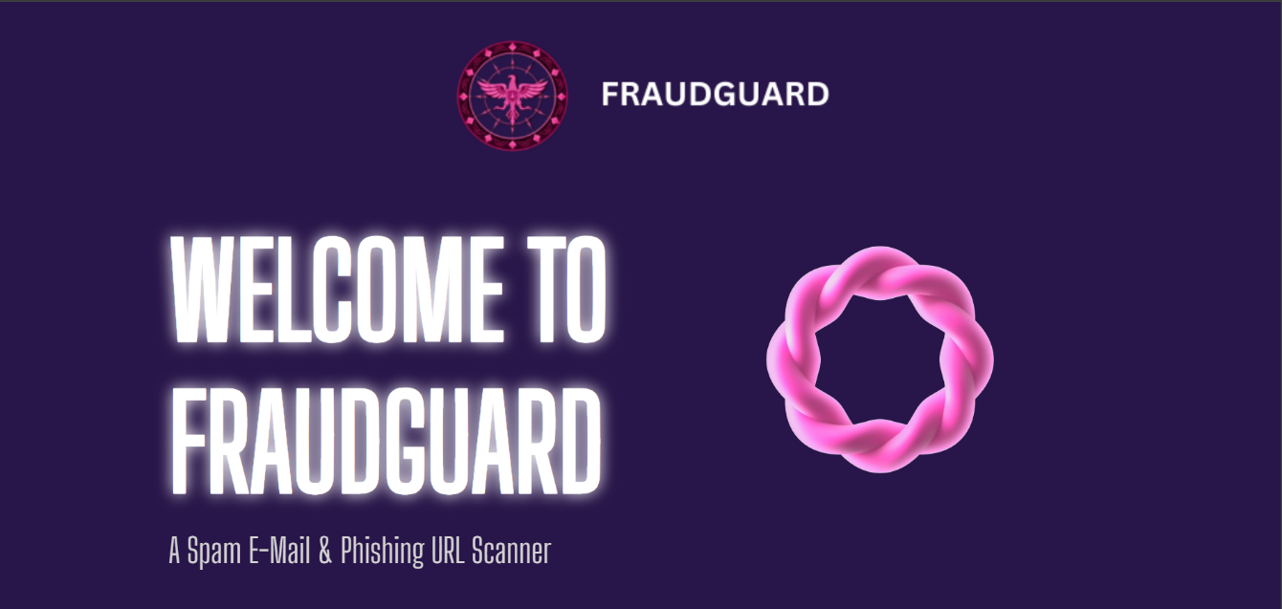**

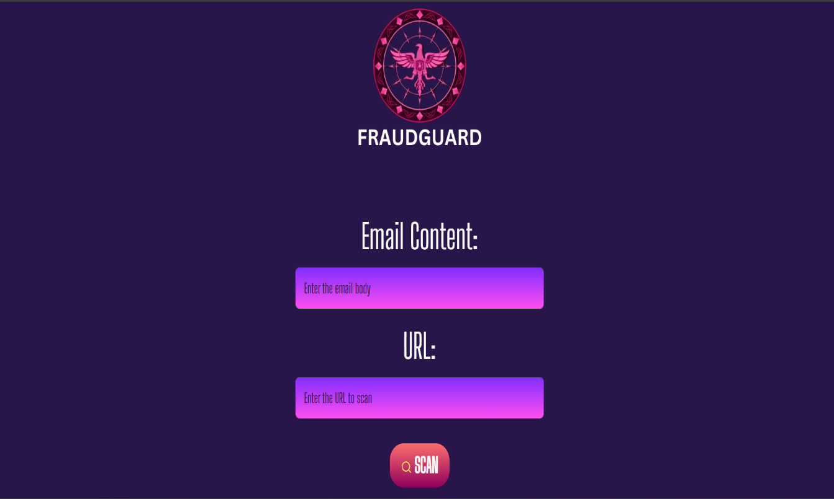

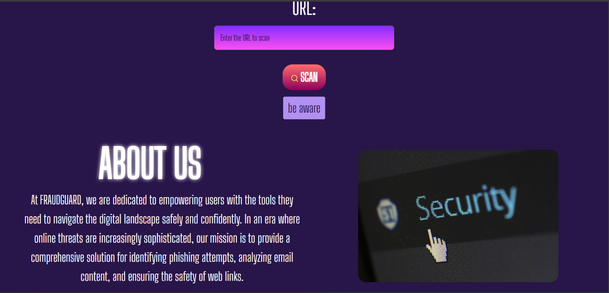

**REFERENCES**

**Few references and problem solving from chat-gpt**

**APPENDIX**